# **Overview**

The purpose is to identify trends in prices and discounts and predictions for discounts for televisions sold by Best Buy by comparing two months. Additional analysis of the inventory such as highest selling, lowest selling based on brand, TV size, TV type and pixel type will also be done. This is an extension of BestBuy Project 3.

# **Review of current Flask App**

The App from Project 3 used data scraped from the BestBuy Canada website. This data was use to show the following on a dashboard:

1. Display inventory in a table format, which could be filtered by the following:
   1. Brand
   2. Type
   3. Size
   4. Pixel
2. Graphs showing average price by brand in line, marker and line+marker format.
3. Map showing BestBuy locations in Ontario.

# **Requirements & Analysis**

## Data Collection

### Refine Data Preprocessing

* 1. If no discount found, show as zero and not NA
  2. If no price is found, remove the item from the dataset.
  3. Remove Amazon Echo from the dataset, as these are not televisions. Project 3 dataset, show NA for TV type, size and pixels..
  4. Change reviews column from text to numeric (remove parentheses and the word reviews)

### Get Additional Data

* 1. Rerun data collection (web scraping) Python script created in Project 3, with additional updates, as indicated previously..
  2. Add month field to CSV and database to indicate month associated with the data retrieval. Project 3 data will have June, and current data July.
  3. Merge data from Project 3 and current download to create final dataset.

## Data Visualization

### Update Flask App

* 1. Graphs
     1. Bar chart showing number of units by type and pixel based on selected brand from dropdown
     2. Top ten popular TVs overall based on number of reviews.
  2. Map
     1. Update hover info to include address of store location

### Tableau

### Compare months

* + 1. Show TVs on discounts for both periods. showing the discount amount given in each month.
    2. Show TVs with an increase in original price.
    3. Show TVs with a reduction in original price
    4. Show TVs with increase in number of reviews
    5. Increase in number of units by brand over the period
    6. Decrease in number of units by brand over the period

### Miscellaneous Charts

* + 1. Top ten popular TVs (description) overall based on number of reviews
    2. Top 5 popular TVs (description) for a each TV size, TV Type, TV Pixels
    3. Show top 5 TV sizes
    4. Number of units available for sale by month
    5. Number of units available by brand for each month

## Machine Learning

Clustering: groups based on similarity of tv.

Model: predicts the best tv they can choose.

[3:37](https://utorvirtdatap-oxv9509.slack.com/archives/C05B5PZ04LC/p1690141037863879)

## Notes

### Data Limitations

1. Number of reviews is not restricted to just the two month period, but is a representation of total reviews over the life of the product. New TVs could be rated as not being popular..
2. Sale volume (units available, total sales) not supplied by BestBuy website.

### Price Discount

Best Buy Canada website clearly displays regular prices, sale prices and discounts on their website.

* Sale prices are displayed in red;
* Discount is shown as “SAVE $xxx”.
* Regular price in black with no “SAVE $xxx

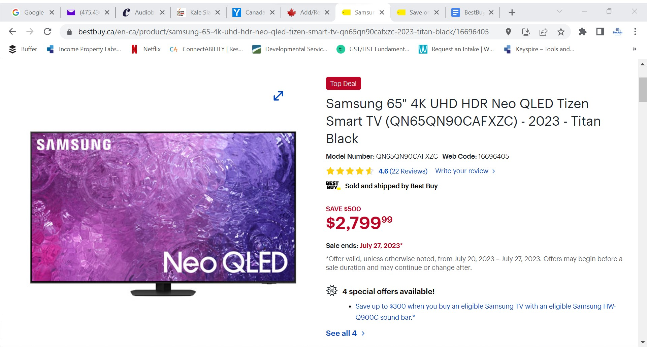

**Figure 1 - Example sale item**

The Order summary as shown in the figure below. is explained as follows:

* Product Subtotal = Sale price ($2799.99) + Discount amount ($500) = $3299.99
* Order discounts = SAVE $500

Therefore, original price = price + discount amount.

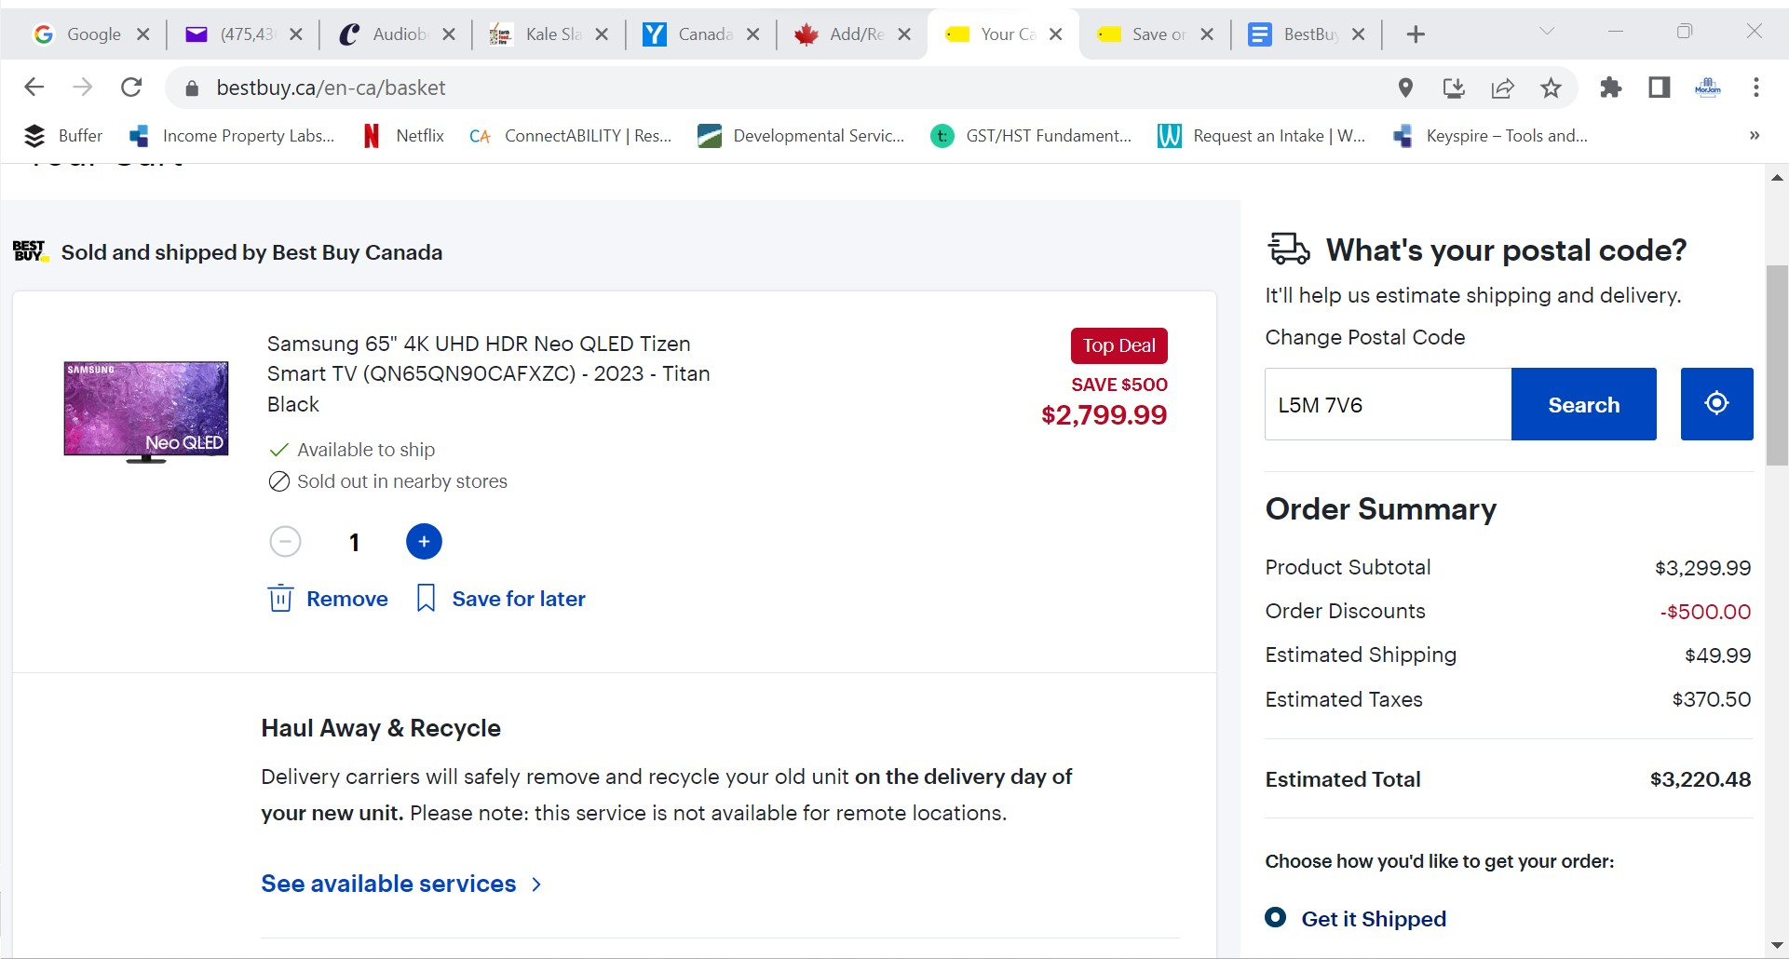

**Figure 2 - Cart showing original price of TV on sale**

# **Work Breakdown Structure**

| **Activity** | **Name** | **Due Date** |
| --- | --- | --- |
| Design and Analysis | Kerry-Ann | July 24 |
| Data Collection and preprocessing | Abisola, Amina | July 24 |
| Update Flask App | Kerry-Ann | July 27 |
| Tableau Charts | Abisola, Amina, Ishita | July 27 |
| Machine Learning | Khurram | July 27 |
| Testing & Review | All | July 31 |
| Project Slides & Presentation | Ishita & Amina | July 31 |
| Final Review and Practice | All | Aug 2 |